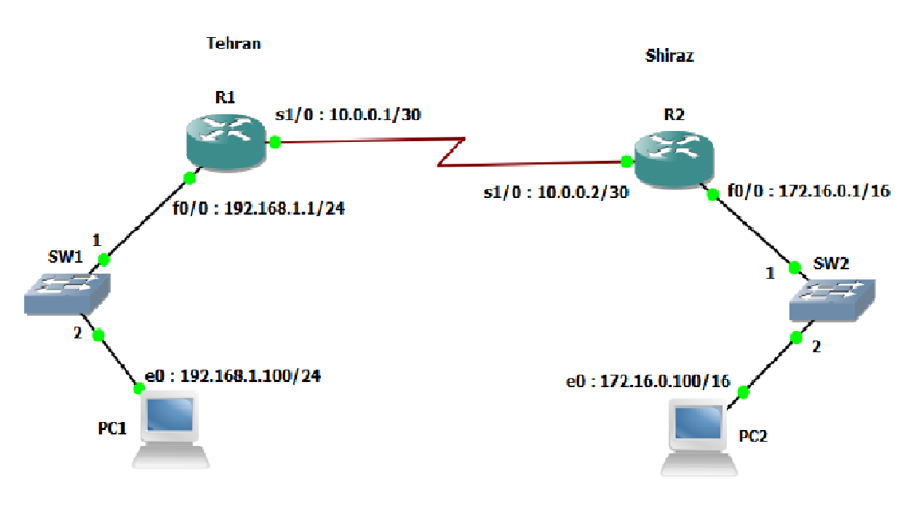

Keep name of R1 -> Your name

Keep name of R2 -> Your Surname

Change address of PC1 BY 192.168.1.last tow digits of your roll number

Change address of PC2 BY 172.16.0..last tow digits of your roll number